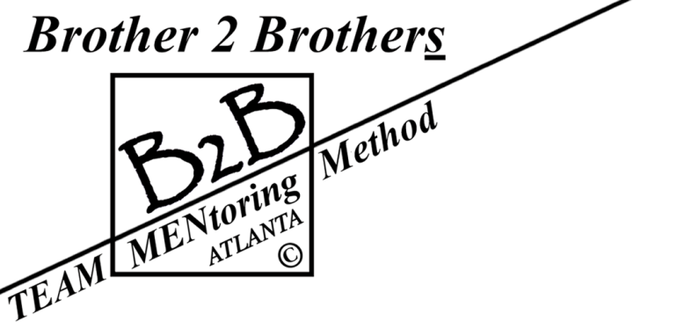
“No boys allowed, only willing MANteens!”

My humble request for your encouraging NON-monetary advocacy

Thank you for reading this e-mail. I am presently working with Atlanta’s Office of Cultural Affairs in their municipally owned art Gallery 72 that is exhibiting some of my Camera Portraits until 4/3/2020 to bring attention to B2B’s call for a few more responsible volunteering men from Atlanta’s community to join our vetted 100% volunteer, NON-501 c3 MENtoring program for the next 2020-21 school year! The gallery’s Artist Talk is scheduled for 3/19/20 at 7 to 8 pm.
Please pass this message on to those you know who might be or know someone fitting our requirements of being a reliable, family centered, married or divorced, seasoned example from our community with Ethical character, 2 years of college minimum who enjoys reading, able to engage in thoughtful 2-way conversations and pass a police background check. Each will receive instructions, a program manual and a gold tie, lapel pin and name tag to be worn with their own black suit (our work uniform) to be prepared for their TEAM.
B2B is a small group of active professionals who have voluntarily life coached in various APS schools since 2007 that included four years at West End Academy and one year at King Middle school under Communities in Schools’ umbrella, independently for one year in Young Middle School and Douglass High School, three years at BEST Academy and two years in Fulton County’s Fulton Leadership Academy.
As community volunteers, B2B MENtors have personally financed our own program needs since our start while working with typically full classrooms of male 12th graders down to the present improved-results-formula that groups every 2 MENtors with the same 8 ninth grade male students to Coach-A-TEAM one hour per week for two semesters at a requesting school. There can be more than one TEAM in a particular school depending on the number of students assigned to us at the school and the available MENtors at that time. Our goal is to expand both while we are also considering the inclusion of the 10th grade based on research.
Together with your help in attracting a few more responsible community MEN to consider volunteering with us, B2B could potentially expand to make a BIG positive difference in the future of many more confused mid-teen males, adding their blessings for a healthier, happier and thriving society! Our plan is not to replace any school program, but to compliment them all.
For Your Information: I am a retired practical artist who dropped out of high school in 1954 and joined the US Air Force before learning to appreciate and value education. I ultimately earning a BFA Degree in Photography from the School of the Art Institute of Chicago and with my wonderful wife Carolyn, who rested eternally in 2017, conducted our Camera Portrait by Dorsey business, commonly called Dorsey Photography, in Chicago from 1971 before moving in 1977 to SW Atlanta until our retirement in 2003 after 32 successful years.

Thank you for your consideration. I may be reached for more details and answers to questions at
404-758-2020 or tomdorsey@bellsouth.net

“It is easier to build strong children than to [attempt to] repair broken men.” – Frederick Douglass.

