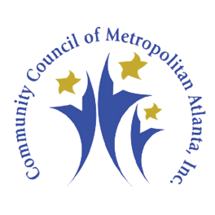
BLACK MALE EMPOWERMENT EXPO
SATURDAY, SEPTEMBER 20, 2014, 11:30 AM – 3:30 PM
MOREHOUSE EXECUTIVE CENTER
830 WESTVIEW DRIVE, SW, ATLANTA, GA 30314

CHURCH PARTNERSHIP FORM

Church: ______________________________________ Contact Person: _______________________
Address: _____________________________________________________________________________
Phone No.: _________________ Fax No: _______________________ Cell No. _______________

Number of males church representatives will bring to the 2014 Male Empowerment Expo: ____________
Please specify age range: __________________________________.
Additional reservations needed::
Name Position/Title Contact No.:
_______________________ ______________________ ________________________
_______________________ ______________________ ________________________
_______________________ ______________________ ________________________
_______________________ ______________________ ________________________
_______________________ ______________________ ________________________

Signed: ___________________________________ Date: __________________

Please fax form to (404) 935-5859 or mail to Community Council of Metropolitan Atlanta, Inc. 80 Walnut Street, Suite103, Atlanta, GA 30314. You may also complete form online at www.communitycouncilma.org.

Thanks for your support!

