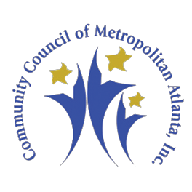

COMMUNITY COUNCIL OF METROPOLITAN ATLANTA, INC.
PRIORITY MALE EMPOWERMENT SYMPOSIUM
THURSDAY, NOVEMBER 14, 2019, 10:00 am – 2:30 pm

Nonprofit Service Provider Form/Priority Male Empowerment Network DATA FORM
Organization:
Address:
Contact Person: |  | Position:
Email Address:
Phone: | Cell No.: |  | Fax No.:
Number of Persons Attending Symposium (Maximum 2):
Please list names of representatives for name tags:
Will your organization participate as a service provider on the Priority Male Empowerment Network?
[ ] Yes [ ] No Remarks:
Description of Agency
Services Provided.

Eligibility Requirements
Other Remarks:

SUBMITTED BY: DATE:
Please return form to: Community Council of Metropolitan Atlanta, Inc via email to info@communitycouncilma.org or fax to (404) 935-5859.
Thank you for your support!

